|  |  |  |  |  |  |  |  |  |  |  |  |  |  |  |  |  |  |  |  |  |  |  |  |  |  |  |  |  |  |  |  |  |  |  |  |  |  |  |  |  |  |  |  |  |  |  |  |  |  |  |  |  |  |  |  |  |  |  |  |  |  |  |  |  |  |  |  |  |  |  |  |  |  |  |  |  |  |  |  |  |  |  |  |  |  |  |  |  |  |  |  |  |  |  |  |  |  |  |  |  |  |  |  |  |  |  |  |  |  |  |  |  |  |  |  |  |  |  |  |  |  |  |  |  |  |  |  |  |  |  |  |  |  |  |  |  |  |  |  |  |  |  |  |  |  |  |  |  |  |  |  |  |  |  |  |  |  |  |  |  |  |  |  |  |  |  |
| --- | --- | --- | --- | --- | --- | --- | --- | --- | --- | --- | --- | --- | --- | --- | --- | --- | --- | --- | --- | --- | --- | --- | --- | --- | --- | --- | --- | --- | --- | --- | --- | --- | --- | --- | --- | --- | --- | --- | --- | --- | --- | --- | --- | --- | --- | --- | --- | --- | --- | --- | --- | --- | --- | --- | --- | --- | --- | --- | --- | --- | --- | --- | --- | --- | --- | --- | --- | --- | --- | --- | --- | --- | --- | --- | --- | --- | --- | --- | --- | --- | --- | --- | --- | --- | --- | --- | --- | --- | --- | --- | --- | --- | --- | --- | --- | --- | --- | --- | --- | --- | --- | --- | --- | --- | --- | --- | --- | --- | --- | --- | --- | --- | --- | --- | --- | --- | --- | --- | --- | --- | --- | --- | --- | --- | --- | --- | --- | --- | --- | --- | --- | --- | --- | --- | --- | --- | --- | --- | --- | --- | --- | --- | --- | --- | --- | --- | --- | --- | --- | --- | --- | --- | --- | --- | --- | --- | --- | --- | --- | --- | --- | --- | --- | --- | --- | --- |
| |  |  |  | | --- | --- | --- | |  | **EU-lidstaten:** | **Hoofdstad:** | | 1 | [België](http://europa.eu/abc/european_countries/eu_members/belgium/index_nl.htm) | Brussel | | 2 | [Bulgarije](http://europa.eu/abc/european_countries/eu_members/bulgaria/index_nl.htm) | Sofia | | 3 | [Cyprus](http://europa.eu/abc/european_countries/eu_members/cyprus/index_nl.htm) | Nicosia | | 4 | [Denemarken](http://europa.eu/abc/european_countries/eu_members/denmark/index_nl.htm) | Kopenhagen | | 5 | [Duitsland](http://europa.eu/abc/european_countries/eu_members/germany/index_nl.htm) | Berlijn | | 6 | [Estland](http://europa.eu/abc/european_countries/eu_members/estonia/index_nl.htm) | Tallinn | | 7 | [Finland](http://europa.eu/abc/european_countries/eu_members/finland/index_nl.htm) | Helsinki | | 8 | [Frankrijk](http://europa.eu/abc/european_countries/eu_members/france/index_nl.htm) | Parijs | | 9 | [Griekenland](http://europa.eu/abc/european_countries/eu_members/greece/index_nl.htm) | Athene | | 10 | [Hongarije](http://europa.eu/abc/european_countries/eu_members/hungary/index_nl.htm) | Boedapest | | 11 | [Ierland](http://europa.eu/abc/european_countries/eu_members/ireland/index_nl.htm) | Dublin | | 12 | [Italië](http://europa.eu/abc/european_countries/eu_members/italy/index_nl.htm) | Rome | | 13 | [Letland](http://europa.eu/abc/european_countries/eu_members/latvia/index_nl.htm) | Riga | | 14 | [Litouwen](http://europa.eu/abc/european_countries/eu_members/lithuania/index_nl.htm) | Vilnius | | 15 | [Luxemburg](http://europa.eu/abc/european_countries/eu_members/luxembourg/index_nl.htm) | Luxemburg | | 16 | [Malta](http://europa.eu/abc/european_countries/eu_members/malta/index_nl.htm) | Valetta | | 17 | [Nederland](http://europa.eu/abc/european_countries/eu_members/netherlands/index_nl.htm) | Amsterdam | | 18 | [Oostenrijk](http://europa.eu/abc/european_countries/eu_members/austria/index_nl.htm) | Wenen | | 19 | [Polen](http://europa.eu/abc/european_countries/eu_members/poland/index_nl.htm) | Warschau | | 20 | [Portugal](http://europa.eu/abc/european_countries/eu_members/portugal/index_nl.htm) | Lissabon | | 21 | [Roemenië](http://europa.eu/abc/european_countries/eu_members/romania/index_nl.htm) | Boekarest | | 22 | [Slovenië](http://europa.eu/abc/european_countries/eu_members/slovenia/index_nl.htm) | Ljubljana | | 23 | [Slowakije](http://europa.eu/abc/european_countries/eu_members/slovakia/index_nl.htm) | Bratislava | | 24 | [Spanje](http://europa.eu/abc/european_countries/eu_members/spain/index_nl.htm) | Madrid | | 25 | [Tsjechië](http://europa.eu/abc/european_countries/eu_members/czechrepublic/index_nl.htm) | Praag | | 26 | [Verenigd Koninkrijk](http://europa.eu/abc/european_countries/eu_members/unitedkingdom/index_nl.htm) | Londen | | 27 | [Zweden](http://europa.eu/abc/european_countries/eu_members/sweden/index_nl.htm) | Stockholm | | **29** | [Kroatië](http://europa.eu/abc/european_countries/candidate_countries/croatia/index_nl.htm) | Zagreb | |  | Kandidaat lidstaten: |  | | 28 | [IJsland](http://europa.eu/abc/european_countries/candidate_countries/iceland/index_nl.htm) | Reykjavik | | 30 | [Turkije](http://europa.eu/abc/european_countries/candidate_countries/turkey/index_nl.htm) | Ankara | | 31 | Voormalige Joegoslavische Republiek Macedonië | Skopje | | **42** | [Montenegro](http://europa.eu/abc/european_countries/others/montenegro/index_nl.htm) | Podgorica | | **47** | [Servië](http://europa.eu/abc/european_countries/others/serbia/index_nl.htm) | Belgrado | |  | Andere landen in Europa: |  | | 32 | [Albanië](http://europa.eu/abc/european_countries/others/albania/index_nl.htm) | Tirana | | 33 | [Andorra](http://europa.eu/abc/european_countries/others/andorra/index_nl.htm) | Andorra la Vella | | 34 | [Armenië](http://europa.eu/abc/european_countries/others/armenia/index_nl.htm) | Jerevan | | 35 | [Azerbeidzjan](http://europa.eu/abc/european_countries/others/azerbaijan/index_nl.htm) | Bakoe | | 36 | [Bosnië en Herzegovina](http://europa.eu/abc/european_countries/others/bosniaherzegovina/index_nl.htm) | Sarajevo | | 37 | [Georgië](http://europa.eu/abc/european_countries/others/georgia/index_nl.htm) | Tbilisi | | 38 | Kosovo | Pristina | | 39 | [Liechtenstein](http://europa.eu/abc/european_countries/others/liechtenstein/index_nl.htm) | Vaduz | | 40 | [Moldavië](http://europa.eu/abc/european_countries/others/moldova/index_nl.htm) | Chisinau | | 41 | [Monaco](http://europa.eu/abc/european_countries/others/monaco/index_nl.htm) | Monaco | | **43** | [Noorwegen](http://europa.eu/abc/european_countries/others/norway/index_nl.htm) | Oslo | | 44 | [Oekraïne](http://europa.eu/abc/european_countries/others/ukraine/index_nl.htm) | Kiev | | 45 | [Rusland](http://europa.eu/abc/european_countries/others/russia/index_nl.htm) | Moskou | | 46 | [San Marino](http://europa.eu/abc/european_countries/others/sanmarino/index_nl.htm) | San Marino | | **48** | [Staat Vaticaanstad](http://europa.eu/abc/european_countries/others/vatican/index_nl.htm) | Vaticaanstad | | 49 | [Wit-Rusland](http://europa.eu/abc/european_countries/others/belarus/index_nl.htm) | Minsk | | 50 | [Zwitserland](http://europa.eu/abc/european_countries/others/switzerland/index_nl.htm) | Bern | | | | | | | |  | | --- | | **België**  **EU-lid sinds**: De oprichting **Staatsvorm**: Constitutionele monarchie  **Hoofdstad**: Brussel  **Oppervlakte**: 30.528 km²  **Bevolking**: 10,7 miljoen  **Munteenheid**: euro  **Luister naar de talen**[: Nederlands,](http://europa.eu/abc/european_countries/languages/dutch/index_nl.htm?_nl)  [Frans](http://europa.eu/abc/european_countries/languages/french/index_nl.htm?_fr)[, Duits](http://europa.eu/abc/european_countries/languages/german/index_nl.htm?_de) | |
|  | **Zeeën en oceanen** | **Stromen** | | **Gebergtes** | | |
| **A:** | Atlantische Oceaan | a: | Rijn | **I:** | Pyreneeën | |
| **B** | Middellandse Zee | b: | Donau | **II:** | Alpen | |
| **C** | Noordzee | c: | Po | **III:** | Scandinavisch Hoogland | |
| **D:** | Zwarte Zee | d: | Seine | **IV:** | Kaukasus | |
| **E:** | Kaspische Zee | e: | Theems | **V:** | Oeral | |
| **F:** | Noordelijke IJszee |  | |  | | |

Oceanen (Romeinse cijfers):

-----------------------------------------------------

1. : Grote Oceaan of Stille Oceaan
2. : Atlantische Oceaan
3. : Indische oceaan

IV: Noordelijke IJszee

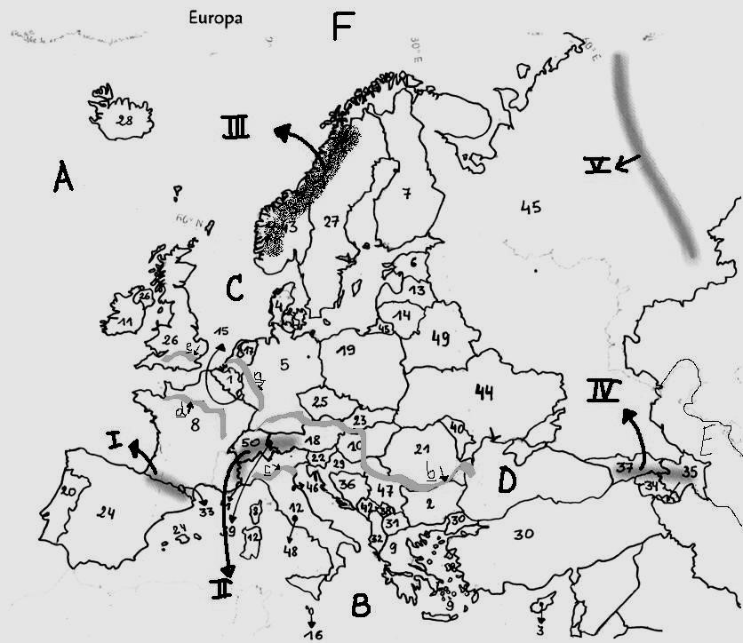

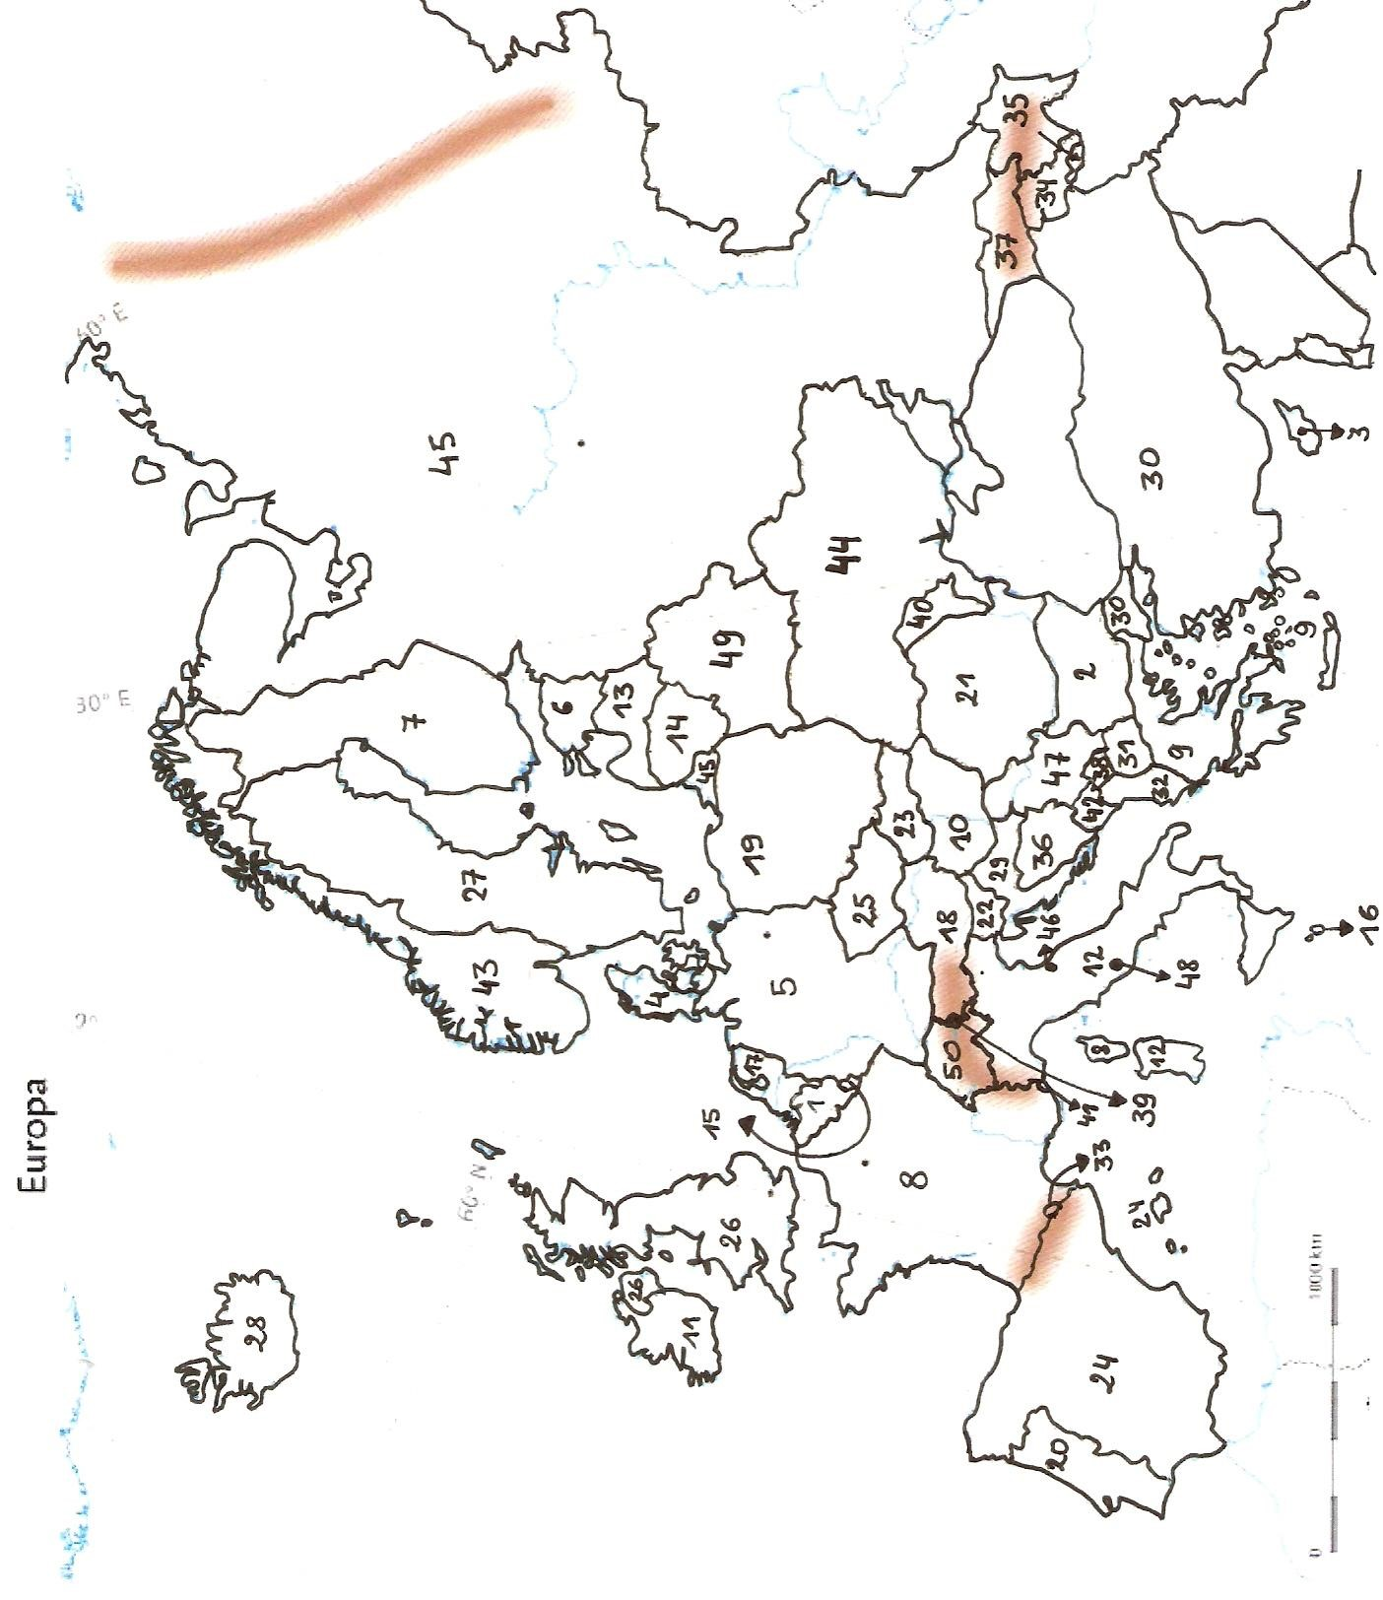

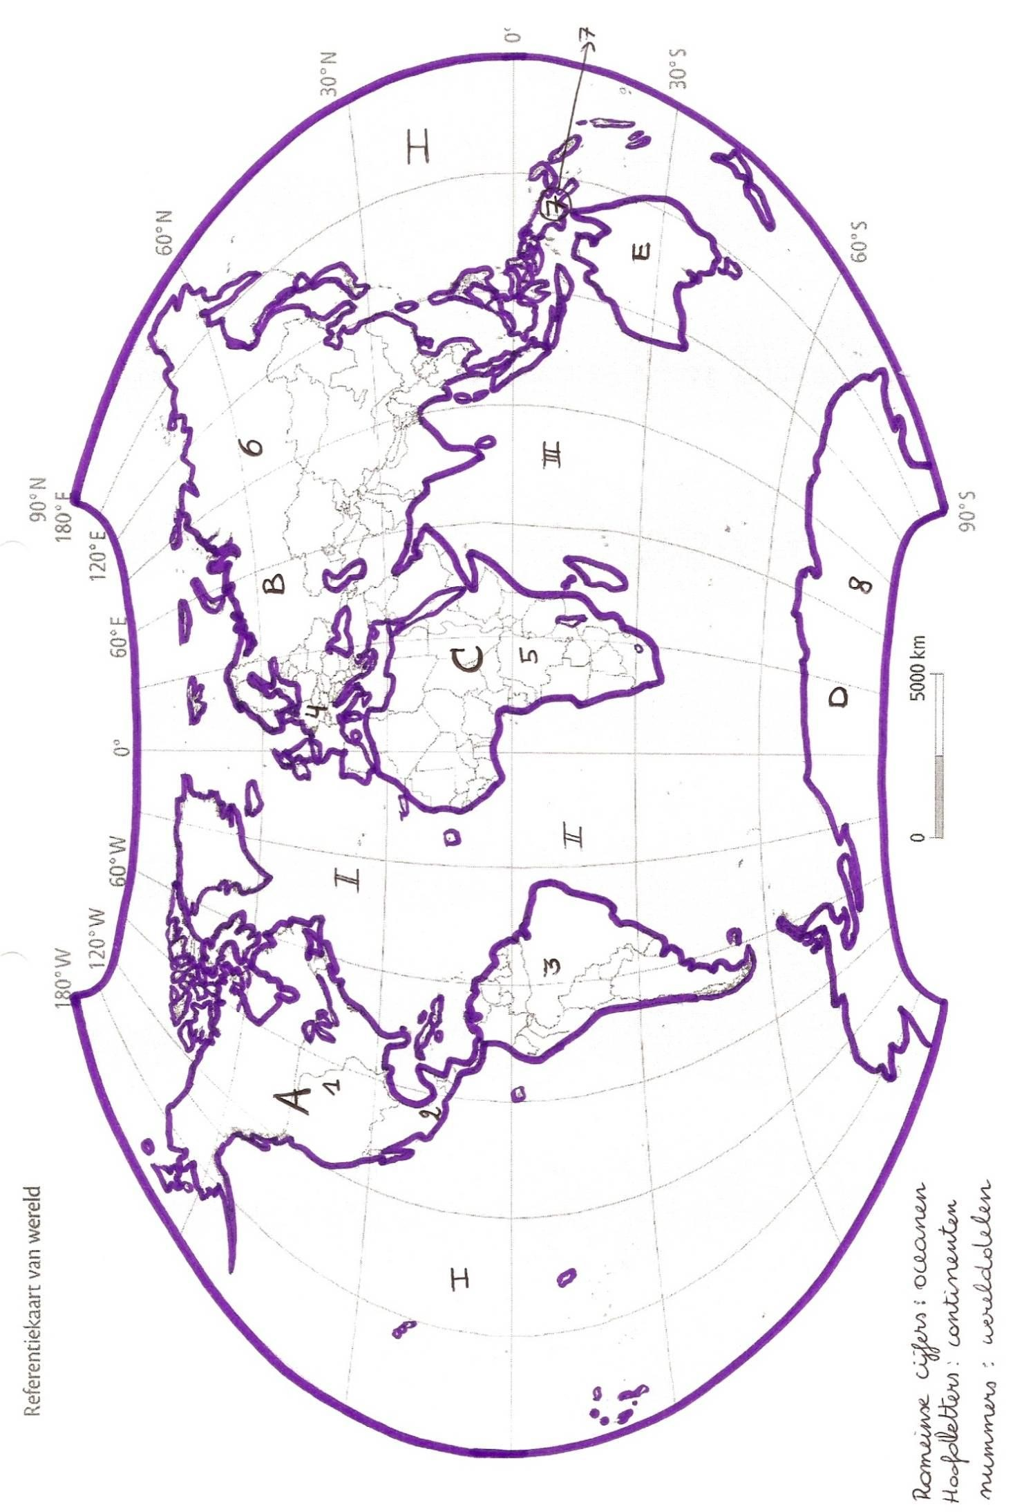

IV

DE AARDE RELIËF, RIVIEREN, ZEEËN

|  |
| --- |
| RELIËFGEBIEDEN |
| 1 Rocky Mountains |
| 2 Andesgebergte |
| 3 Atlasgebergte |
| 4 Himalaya |
| 5 Australische Alpen |
| 6 Great Plains |
| 7 Dekanplateau |
| 8 Mississippivlakte |
| 9 Amazonevlakte |
| RIVIEREN |
| 10 Mississippi |
| 11 Amazone |
| 12 Nijl |
| 13 Indus |
| 14 Ganges |
| 15 Gele rivier |
| 16 Blauwe rivier |
| ZEEËN |
| 17 Middellandse Zee |
| 18 Noordzee |
| 19 Zwarte Zee |
| 20 Kaspische Zee |

